Course Title: Social Immersive Learning
Course Code: 24UC0022
Name: L.Ishitha
Roll No: 2420030041
Section: 10s
Project Expo: Code The Core

Organized by:
KLH Bachupally Campus is conducting a Project Expo on 'Bridging Minds Through Networks'. The event showcases innovative student projects and promotes collaboration through technology and ideas.

Dates:
11-10-2025 | 12:00 PM to 04:00 PM

Event Summary:
The Project Expo titled 'Bridging Minds Through Networks' was held at KLH Bachupally campus. The event provided a platform for students to present their innovative projects, share creative ideas, and demonstrate how technology can bridge communication and collaboration among individuals. It encouraged teamwork, innovation, and critical thinking while fostering a spirit of research and development. Students showcased projects from diverse domains, emphasizing real-world applications and problem-solving.

Key Highlights:
• Wide range of projects displayed across multiple domains.
• Encouragement for interdisciplinary collaboration.
• Guidance from faculty mentors and expo coordinators.
• Emphasis on innovation, teamwork, and creativity.
• Opportunities for students to gain feedback and recognition.

My Participation:
I participated in the Project Expo by presenting my innovative project idea that aligns with the theme 'Bridging Minds Through Networks'. It was a great opportunity to share my technical skills and learn from peers. Through this event, I gained valuable insights into teamwork, communication, and presentation skills. The feedback from mentors and coordinators helped me understand areas for improvement and motivated me to continue exploring creative technological solutions.

Event Photographs:
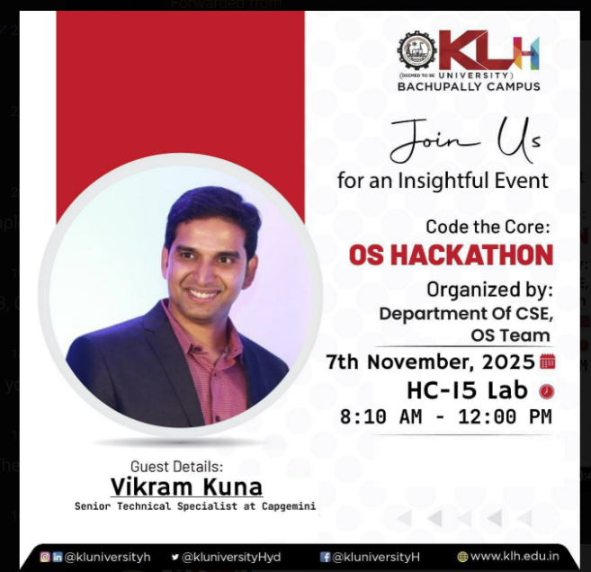

Conclusion:
The Project Expo was a highly enriching experience that provided an excellent platform for learning and innovation. It inspired students to think critically, innovate, and collaborate to create meaningful solutions.

Acknowledgment:
Special thanks to Mr. Shaik Asif, Mrs. K Chandusha, and KLH University for hosting such an informative workshop and for recognizing my performance.

